LINEAR REGRESSION
LINEAR REGRESSION:
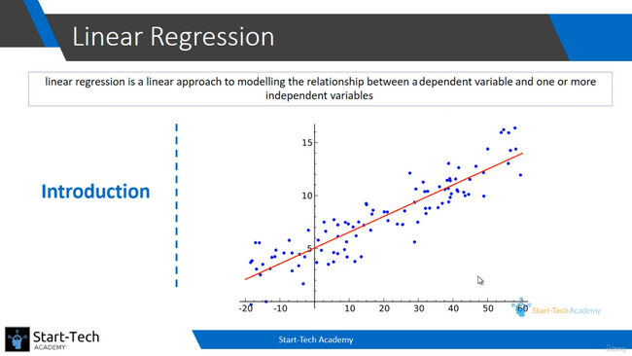
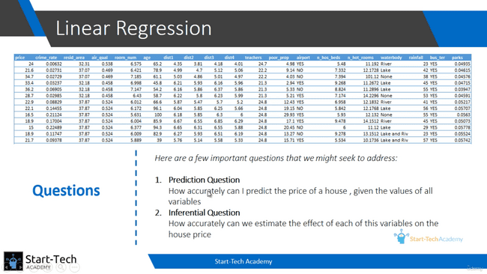
SIMPLE LINEAR REGRESSION:
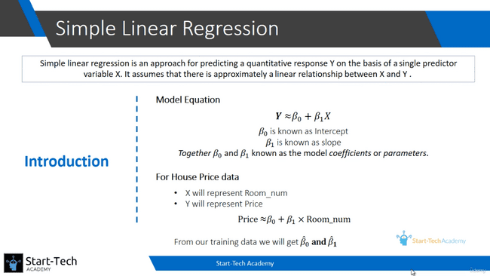
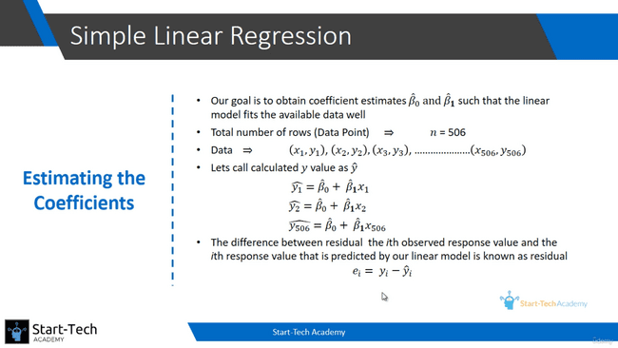
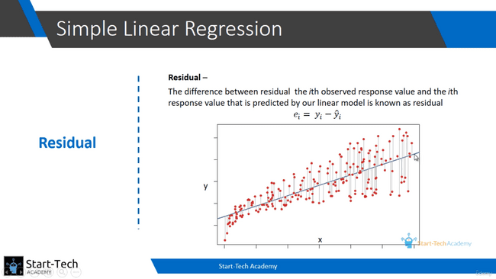
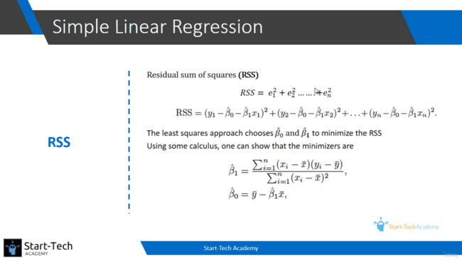
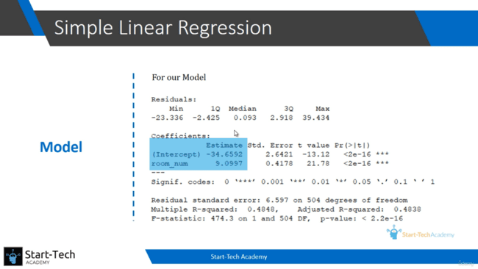
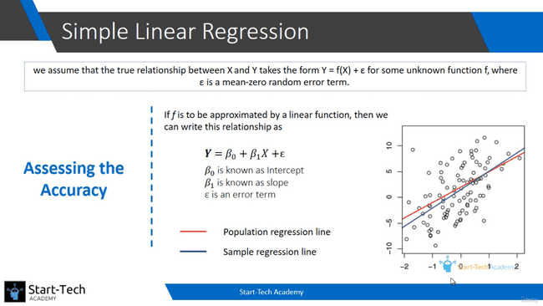
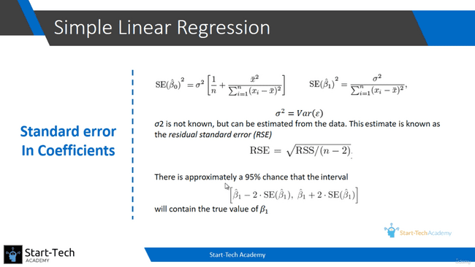
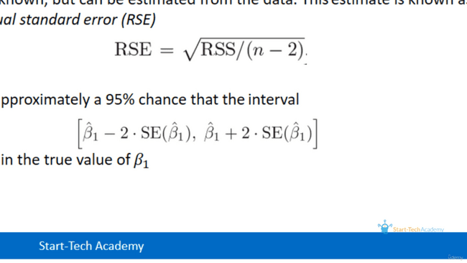
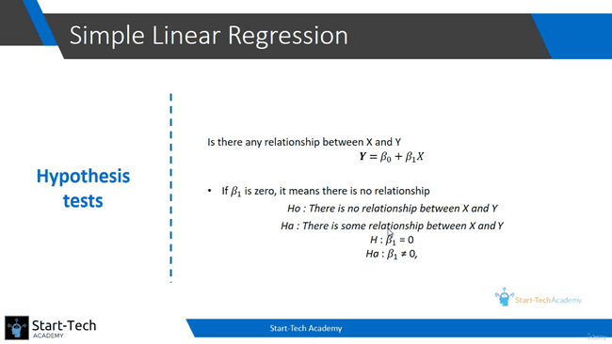
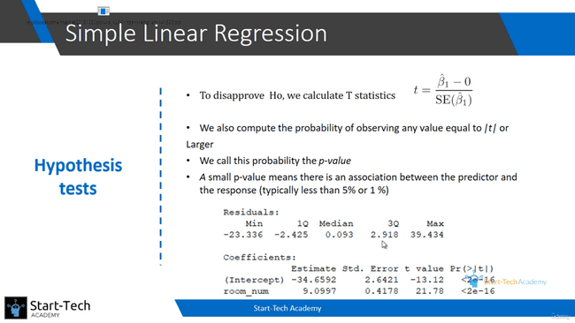
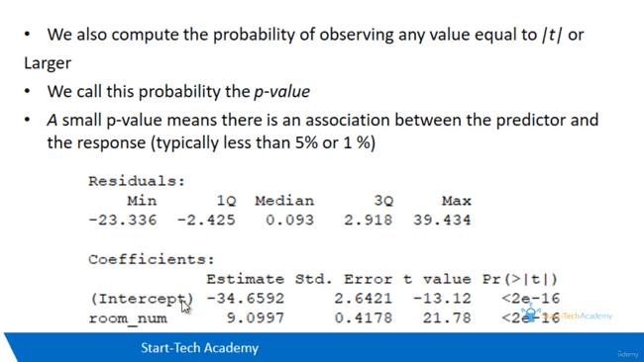
Here Estimate of Intercept is beta0 value and room_num is beta1 value. Std Error(Intercept) is Std Error of beta0 and Std Error(room_num) is Std Error of beta1. Using this Std Error, we can find the interval of beta1. 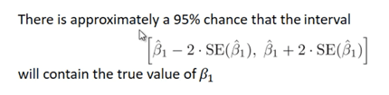
Using t value and p value, we can test the hypothesis. Here p value is really small, that means there is a relationship between X and Y.
QUALITY OF FIT:
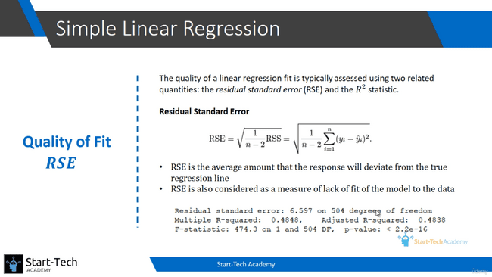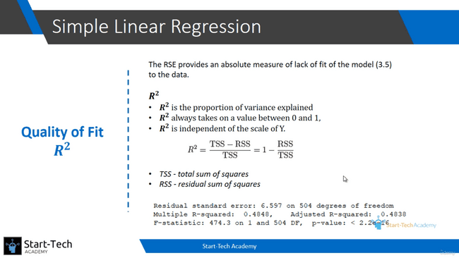 If R square is close to 1, then the model is good fit. If it is close to 0, it doesn’t consider good fit. But if we have a marketing data, and having R square value over 0.5, we can consider the model. We need to always look Adjusted R square value.

MULTIPLE LINEAR REGRESSION:
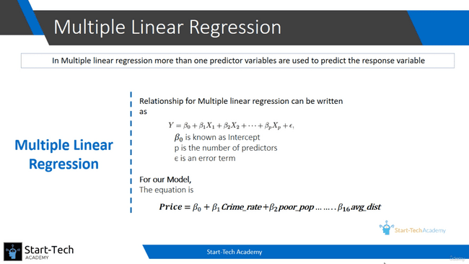
Here, if crime_rate increases by 1 unit, then price will increase by beta1 units. Likewise, if avg_dist increases by 1 unit, then price will increase by beta16 units.
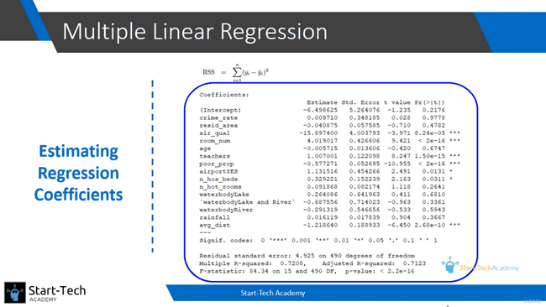
F-Statistic:
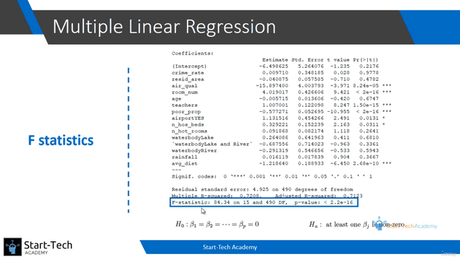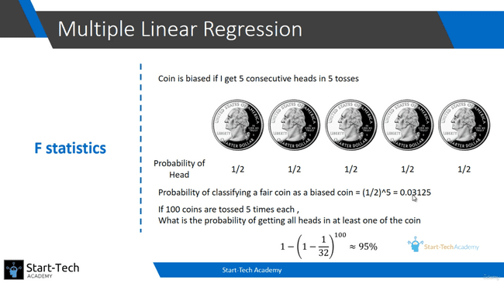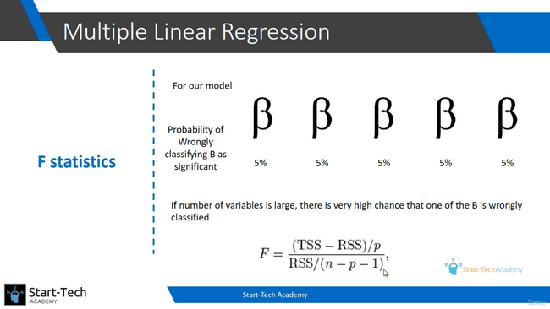
If we take 1 coin, there is only very low possibility of getting all heads for 5 times. But if we toss 100 coins at once, there is high possibility of getting one coin getting all heads for 5 times.
Likewise, we cannot take one variable’s p-value to get the relationship. We need to check the p-value of (F-statistic) all variable and it needs to be lower than 1% or 5% threshold value.
Categorical value:
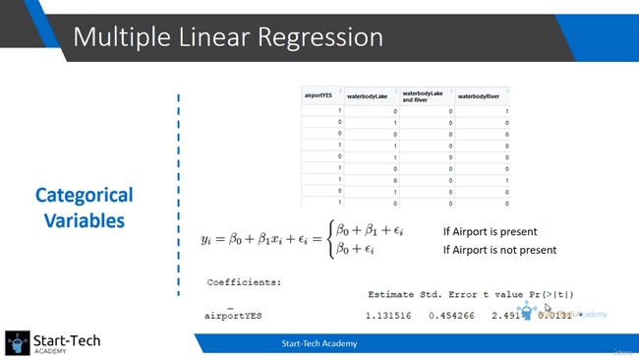
p-value is very low, so there is a statistical evidence of a difference in house price depending on whether there is an airport or whether there is not an airport.
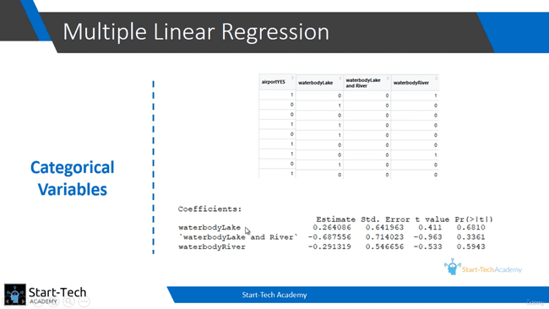
p-value is not that low. So there is no statistical evidence that there will be an impact of these three variables on the house price.
TEST-TRAIN SPLIT:
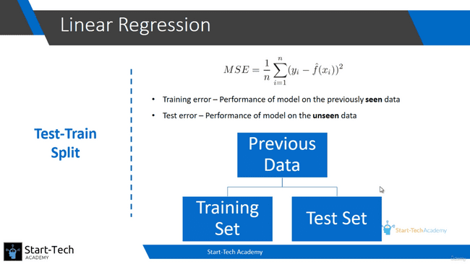
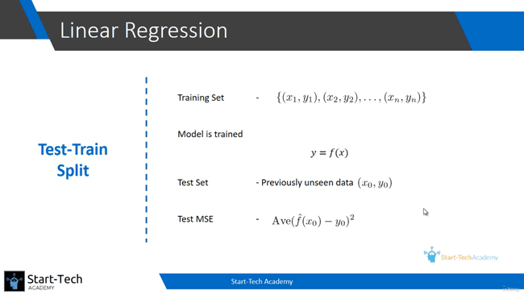
We are only interested in testing the unseen data. So we will train the model with separate data and test them with a separate unseen data.
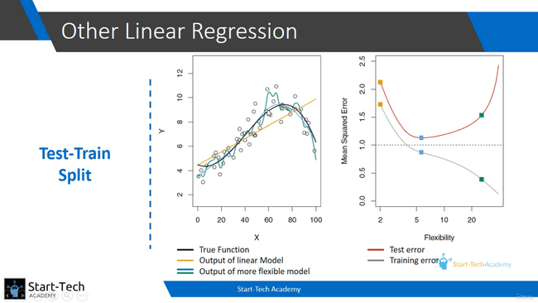
You can see in the above, the First one is Training data graph and the second one is testing data graph. In the first graph, the green curve meeting all the points but testing error is increasing at the green point. But the blue curve is minimizing the testing error and the training data also meeting most of the points.
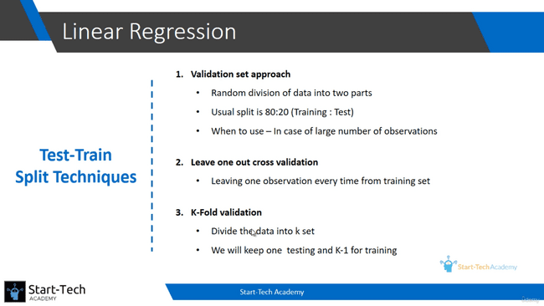
- Split 80% data for training and 20% for testing.
- It leaves one observation for testing each time. We need to run ‘n’ times. It is computationally expensive.
- Divide the data into k-set and we will use k-1 for training and remaining for testing.
Bias-Variance Trade off:
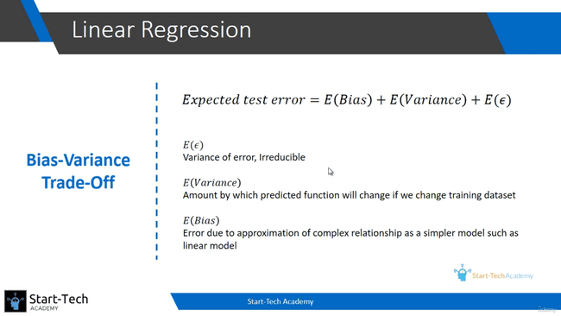
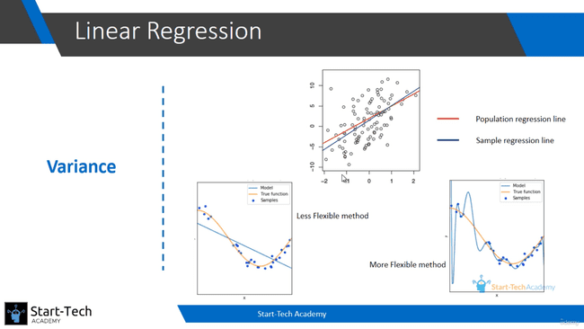
If the flexibility is more, there is high variance. The phenomenon of following the data too closely results in following the error in the observations. It is called over-fitting. When we over-fit we do get low training error but the test error increases.
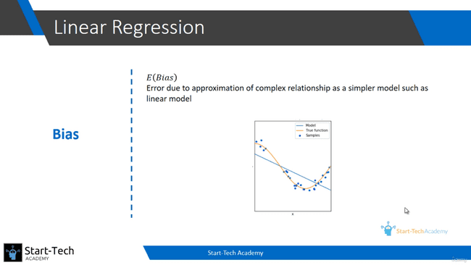
We may be trying to fit a linear model between dependent and independent variables where a linear relationship is unlikely. Increase flexibility, bias error reduces.
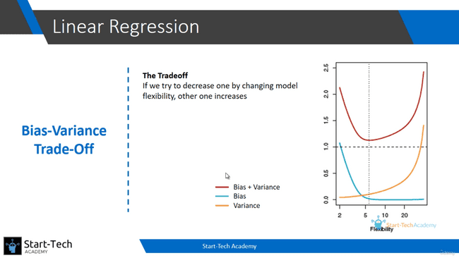
We need to find the lowest point of bias + variance.
REGRESSION MODELS OTHER THAN OLS:
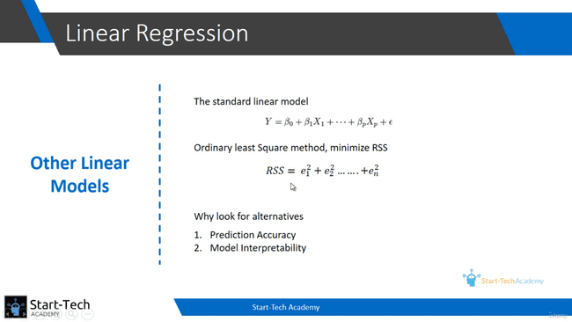
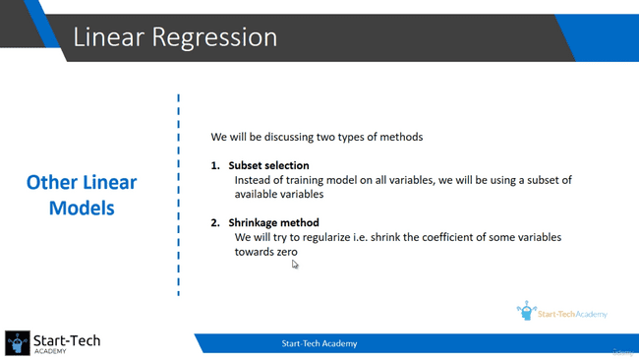
SUBSET SELECTION:
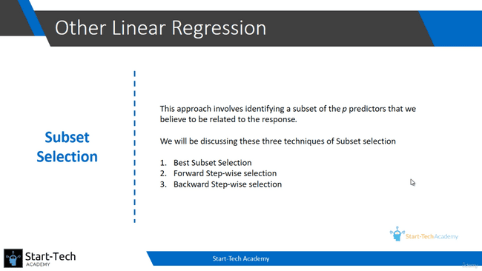
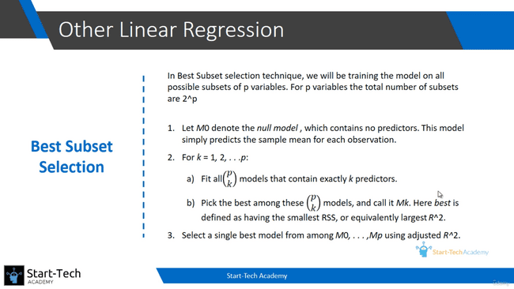
If we have three predictor variables, we need to run the model for 4 times. First, run without any predictor variable and call it as M0. Secondly run with one predictor variable with all combination, like run for room_num variable, run for teacher_ratio variable and also run for air_qual variable and select the best model and call it as M1. Thirdly run with two predictor variable with all combination and get the best and call it as M2. Finally run with three predictor variable with all combination and get the best and call it M3.
Now using Adjusted R^2 for all M0, M1, M2 and M3. Select the best model.
The above “best subset selection method” is computationally expensive.
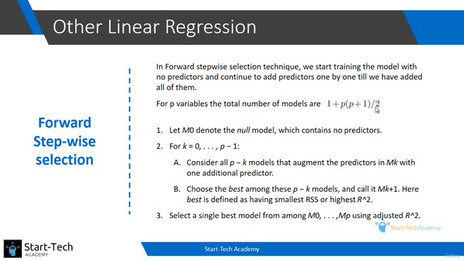
In this method, if we are having three predictor variables say x1, x2, x3, then first we will run the model with predictor variable and denote the model as M0. Then we will run with one predictor variable of all combination x1 and x2 and x3 and select the best model and denote as M1. Now, if our x1 variable gives best model M1, we will use the combination of x1, x2 and x1, x3 and select the model and denote as M2 and similarly for M3 as well. It is computationally not that much expensive then ‘best subset selection’. But there is loss of guarantee. Eg: If our best model is with x2 and x3 but we will miss that using this method.
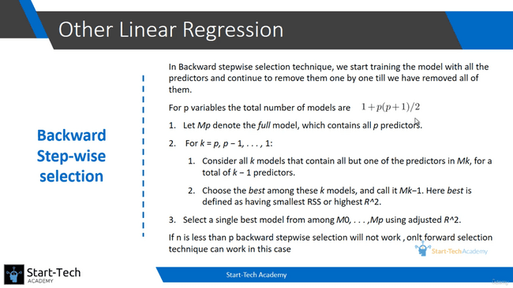
Similar to forward step-wise selection, but we will start with one predictor variable instead of starting with no predictor variable.
If number of variables greater than number of observation, then forward selection method is the one that works.
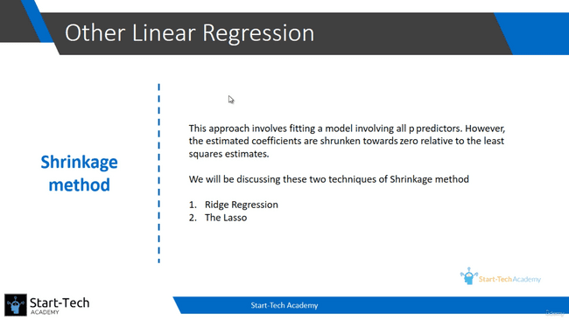
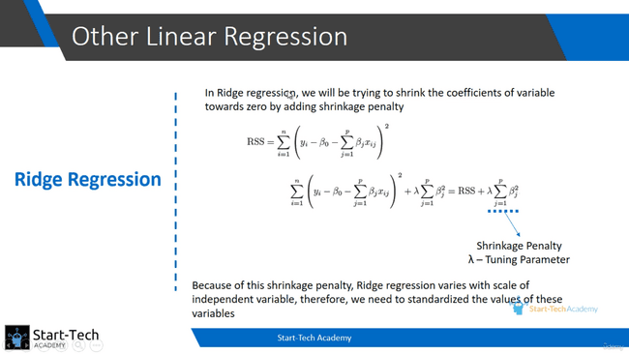
We need to standardize the value of the variables before Ridge regression.
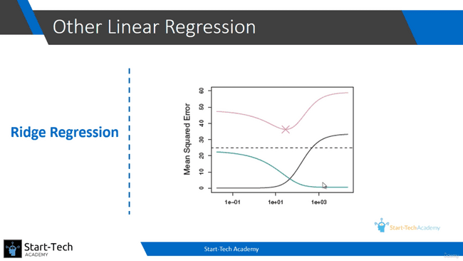
If lambda increases, the variance decreases and the bias increase. We need the certain point of lambda where the sum of the variance and the bias should be at their lowest point.
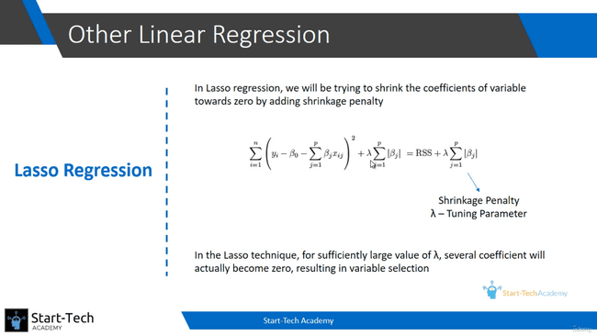
In Lasso, we can able to eliminate some of the variables.
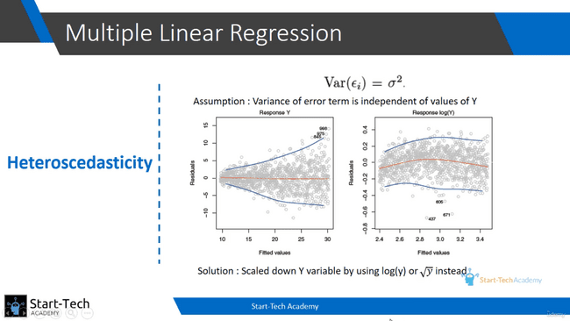
In identifying the confidence interval of beta, we assume sigma as a constant. But in often case, sigma is not constant. That affects the confidence interval, so we take log of y of sq root of y. This may not affects the confidence interval.

